Actuator Sizing
Axis 1(X-Axis) holds: Second belt assembly, Power-screw assembly, external load.
$$m_{total } ≈ 2.07 Kg$$

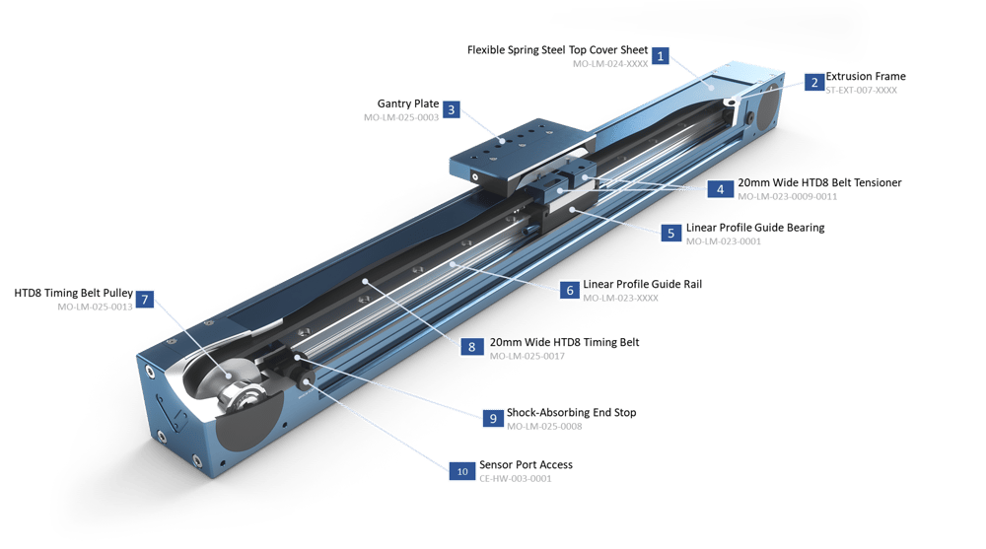
$\sum{T} = Jα$
$$∴T_{m} - T_{L} = (J_{m} + J_{L}) α$$
Inertia of load
$$J_{L} = mr^{2}$$
Where:
m = Total mass of Load | r = radius of pulley
Using a standard pulley: r = 0.637 cm
$$∴ J_{L} = 2070 × {0.673}^{2} = 840 g∙{cm}^{2}$$
For unknown motor, we assume J_{m} = J_{l}:
$$J_{tot} = 2 × 840 = 1680 g∙{cm}^{2}$$

Resistive Torque
To calculate the resistive torque, we use:
$$T_{L} = mgμr$$
Where:
m = Total mass of load | g = Gravitational acceleration
µ = Coefficient of friction | r = radius of pulley
$$∴ T_{L} = 2.07 × 9.81 × 0.05 × 0.637 = 0.65 N∙cm$$
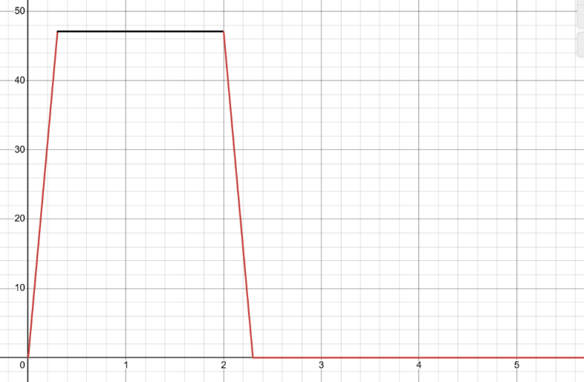
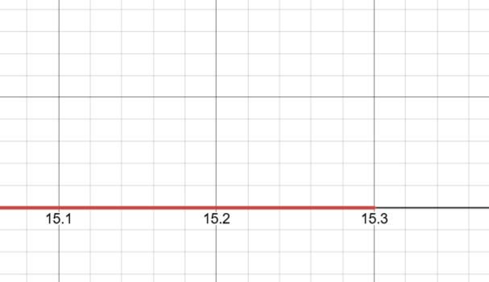
Velocity Profile

1. From t = 0.0s to t = 0.30s:
Constant acceleration: $α = 157 rad∙s^{-2}$
2. From t = 0.30s to t = 2.0s:
Constant speed: $ω = 47.1 rad∙s^{-1}$
3. From t = 2.0s to t = 2.3s:
Constant acceleration: $α = -157 rad∙s^{-2}$
4. From t = 2.3s to t = 15.3s:
Constant speed: $ω =0 rad∙s^{-1}$

Torque
$$T_{m} =( 0.65 + 1680×{10}^{-5} α) N∙cm$$
$$T_{1} = 0.65 + 1680×{10}^{-5} × 157 = 3.2 N∙cm$$ | $$T_{3} = 0.65 + 1680×{10}^{-5} × -157 = -2.0 N∙cm$$
$$T_{2} = 0.65 + 1680×{10}^{-5} ×0 = 0.65 N∙cm$$ | $$T_{4} = 0.65 + 1680×{10}^{-5} × 0 = 0.65N∙cm$$

$$T_{r.m.s} = \sqrt{\frac{T_{1}^{2}×t_{1} + T_{2}^{2}×t_{2}+T_{3}^{2}×t_{3}+T_{4}^{2}×t_{4}}{t_{1}+t_{2}+t_{3}+t_{4}}}$$
$$∴ T_{r.m.s} = \sqrt{\frac{{3.2}^{2}×0.30 +{0.65}^{2}×1.70+{(-2.0)}^{2}×0.30+{0.65}^{2}×13}{15.3}} = 1.28 N∙cm$$
Note: t₄ is the time it takes the Z-axis to complete two cycles (grip and pick up the product)
Choice
We decided to pick NEMA17 stepper motor as our actuator for the following reasons:
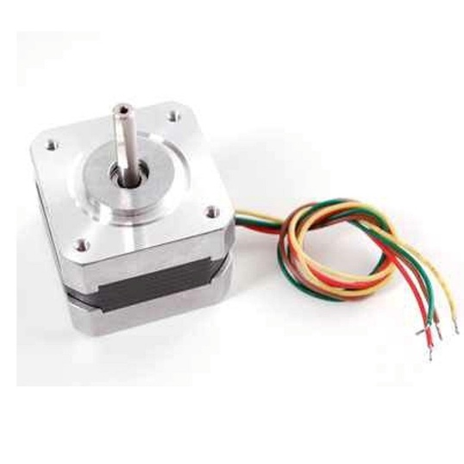
- Both the r.m.s. and maximum torques calculated above fall within the operating limits of the actuator.
- Our assumed motor inertia is much larger than NEMA17’s rotor inertia, meaning there is no doubt that the NEMA17 can easily control the axis.
- Stepper motors provide open-loop control over position, which is needed for controlling the position of the robot.

Axis 2 (Y-Axis) holds: Power-screw assembly, external load.
$$m_{total } ≈ 1.0 Kg$$

$\sum{T} = Jα$
$$∴T_{m} - T_{L} = (J_{m} + J_{L}) α$$
Inertia of load
$$J_{L} = mr^{2}$$
Where:
m = Total mass of Load | r = radius of pulley
Using a standard pulley: r = 0.637 cm
$$∴ J_{L} = 1000 × {0.673}^{2} = 405.7 g∙{cm}^{2}$$
For unknown motor, we assume J_{m} = J_{l}:
$$J_{tot} = 2 × 405.7= 811.4 g∙{cm}^{2}$$

Resistive Torque
To calculate the resistive torque, we use:
$$T_{L} = mgμr$$
Where:
m = Total mass of load | g = Gravitational acceleration
µ = Coefficient of friction | r = radius of pulley
$$∴ T_{L} = 1.0 × 9.81 × 0.05 × 0.637 = 0.31 N∙cm$$
Velocity Profile

1. From t = 0.0s to t = 0.30s:
Constant acceleration: $α = 157 rad∙s^{-2}$
2. From t = 0.30s to t = 2.0s:
Constant speed: $ω = 47.1 rad∙s^{-1}$
3. From t = 2.0s to t = 2.3s:
Constant acceleration: $α = -157 rad∙s^{-2}$
4. From t = 2.3s to t = 15.3s:
Constant speed: $ω =0 rad∙s^{-1}$

Torque
$$T_{m} =( 0.65 + 811.4×{10}^{-5} α) N∙cm$$
$$T_{1} = 0.65 + 811.4×{10}^{-5}× 157 = 1.6 N∙cm$$ | $$T_{3} = 0.65 + 811.4×{10}^{-5} × -157 = -0.97 N∙cm$$
$$T_{2} = 0.65 + 811.4×{10}^{-5} ×0 = 0.65 N∙cm$$ | $$T_{4} = 0.65 + 811.4×{10}^{-5} × 0 = 0.65N∙cm$$

$$T_{r.m.s} = \sqrt{\frac{T_{1}^{2}×t_{1} + T_{2}^{2}×t_{2}+T_{3}^{2}×t_{3}+T_{4}^{2}×t_{4}}{t_{1}+t_{2}+t_{3}+t_{4}}}$$
$$∴ T_{r.m.s} = \sqrt{\frac{{1.6}^{2}×0.30 +{0.65}^{2}×1.70+{(-0.97)}^{2}×0.30+{0.65}^{2}×13}{15.3}} = 0.62 N∙cm$$
Note: t₄ is the time it takes the Z-axis to complete two cycles (grip and pick up the product)
Choice
We decided to pick NEMA17 stepper motor as our actuator for the reasons stated before.

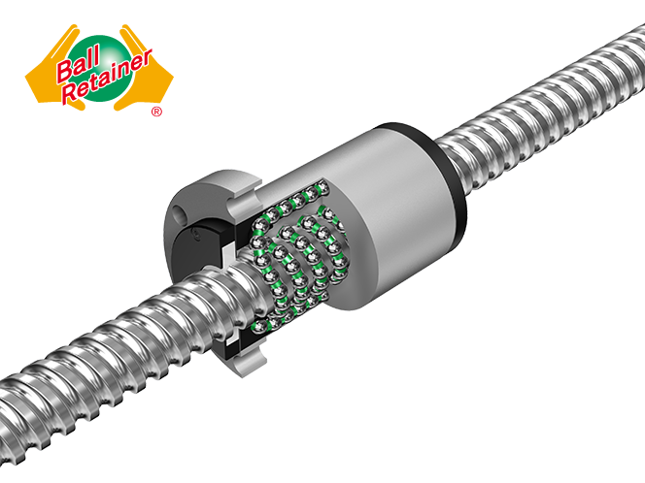
Axis 3 (Z-Axis) holds: Vacuum pump, external load.
$$m_{total } ≈0.4 Kg$$

$$\sum{T} = Jα$$
$$∴T_{m} - T_{L} = (J_{m} + J_{L}) α$$
Inertia of load
$$J_{L} = J_{screw} + J_{load} = (\frac{1}{2} × m_{screw} × r_{screw}^{2}) + (m_{load}×{(\frac{P}{2π})}^{2})$$
Where:
P = Pitch of screw
Using a standard 20 cm screw:
$$∴ J_{L} = 6.4×{10}^{-7} + 0.4 ×{(\frac{0.08}{2π} )}^{2} = 12.9 N∙{cm}^{2}$$
For unknown motor, we assume J_{m} = J_{l}:
$$J_{tot} = 2 × 12.9 = 25.8 g∙{cm}^{2}$$

Resistive Torque
To calculate the resistive torque, we use:
$$T_{L} =\frac{mgP}{2πη}$$
Where:
m = Total mass of load | g = Gravitational acceleration
P = Pitch of Screw | η = Efficiency
$$∴ T_{L} =\frac{0.4 × 9.81 × 0.008}{2π × 0.5} = 1 N∙cm$$
Velocity Profile
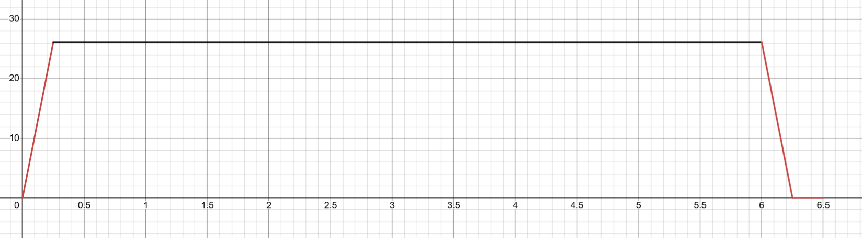

1. From t = 0.0s to t = 0.25s:
Constant acceleration: $α = 104.7 rad∙s^{-2}$
2. From t = 0.25s to t = 6.0s:
Constant speed: $ω = 26.18 rad∙s^{-1}$
3. From t = 6.0s to t = 6.25s:
Constant acceleration: $α = -104.7 rad∙s^{-2}$
4. From t = 6.25s to t = 6.5s:
Constant speed: $ω =0 rad∙s^{-1}$

Torque
$$T_{m} =( 1+ 25.8×{10}^{-5} α) N∙cm$$
$$T_{1} = 1+ 25.8×{10}^{-5} × 104.7= 1.027 N∙cm$$ | $$T_{3} = 1+ 25.8×{10}^{-5} × -104.7 = 0.973 N∙cm$$
$$T_{2} = 1+ 25.8×{10}^{-5} ×0=1.0 N∙cm$$ | $$T_{4} = 1+ 25.8×{10}^{-5} × 0=1.0 N∙cm$$

$$T_{r.m.s} = \sqrt{\frac{T_{1}^{2}×t_{1} + T_{2}^{2}×t_{2}+T_{3}^{2}×t_{3}+T_{4}^{2}×t_{4}}{t_{1}+t_{2}+t_{3}+t_{4}}}$$
$$∴ T_{r.m.s} = \sqrt{\frac{{1.027}^{2}×0.25 +{1.0}^{2}×5.75+{0.973}^{2}×0.25+1^{2}×0.25}{15.3}} = 1.0 N∙cm$$
Choice
We decided to pick 25GA-370 motor with encoder as our actuator for the following reasons:
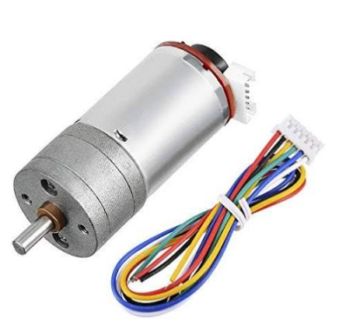
- Both the r.m.s. and maximum torques calculated above fall within the operating limits of the actuator.
- Our assumed motor inertia is larger than rotor inertia, meaning there is no doubt that the actuator can easily control the axis.
- This motor will allow us to perform PID control on the Z-axis.

End Effector
Our Choice of an end effector is a vacuum pump with a suction cup diameter of 25mm.
$$F = P∙A$$
P = Pressure difference provided by pump | A = Area of suction cup
Where:

Required force is equivalent to the weight of the product; Assuming the mass of the product is 50g, we get:
$$0.050 × 9.81 = P × \frac{π}{4}×{(25×{10}^{-3})}^{2}$$
Solving this we get that the required pressure difference P = 1.0 Kpa.
Choice
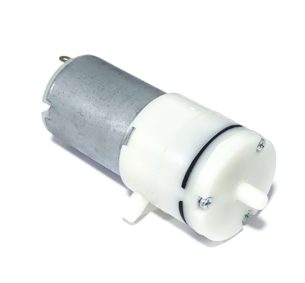
A 12V vacuum pump able to deliver 66Kpa of negative pressure, which makes it more that suitable for the job!

Feeding
The feeder is a rack and pinion mechanism that should be able to push 8 products at once.
As we already know:
$$T_{m} =T_{L} + (J_{m} + J_{L}) α$$
Inertia of load
Modeling the rack as a cuboid with dimentions $1×2×15$ cm
And the pinion as a cylinder with diameter = 10 cm and thickness = 1 cm
And switching the load from translational to effective rotational inertia we get:
$$J_{L} = \frac{1}{2}×(700×π×{0.05}^{2}×0.01) × {0.05}^{2}+ (700 ×0.15×0.02×0.01)×{0.05}^{2}+8×0.05×{0.05}^{2} = 1.12×{10}^{-3} Kg∙m^{2}$$
For unknown motor, we assume J_{m} = J_{l}:
$$J_{tot} = 2 × 1.12×{10}^{-3} = 2.24×{10}^{-3} g∙{cm}^{2}$$
Resistive Torque
To calculate the resistive torque, we use:
$$T_{L} = mgμr$$
Where:
m = Total mass of load | g = Gravitational acceleration
µ = Coefficient of friction | r = radius of pinion
$$∴ T_{L} = 8 × 0.05 × 9.81 × 0.5 × 0.05= 0.0981 N∙m$$

Velocity Profile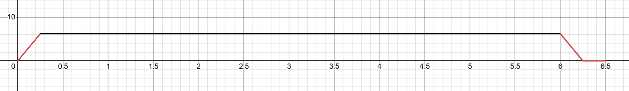

1. From t = 0.0s to t = 0.25s:
Constant acceleration: $α = 25 rad∙s^{-2}$
2. From t = 0.25s to t = 6.0s:
Constant speed: $ω = 6.16 rad∙s^{-1}$
3. From t = 6.0s to t = 6.25s:
Constant acceleration: $α = -25 rad∙s^{-2}$
4. From t = 6.25s to t = 6.5s:
Constant speed: $ω =0 rad∙s^{-1}$
Torque
$$T_{m} =( 0.0981+ 2.24×{10}^{-3} α) N∙m$$
$$T_{1} = 0.0981+ 2.24×{10}^{-3}× 25 = 0.1541 N∙m$$ | $$T_{3} = 0.0981+ 2.24×{10}^{-3}× 25= 0.1541 N∙m$$
$$T_{2} = 0.0981+ 2.24×{10}^{-3}×0=0.0981 N∙m$$ | $$T_{4} =0.0981+ 2.24×{10}^{-3}× 0=0.0421 N∙m$$

$$T_{r.m.s} = \sqrt{\frac{T_{1}^{2}×t_{1} + T_{2}^{2}×t_{2}+T_{3}^{2}×t_{3}+T_{4}^{2}×t_{4}}{t_{1}+t_{2}+t_{3}+t_{4}}}$$
$$∴ T_{r.m.s} = \sqrt{\frac{{0.1541}^{2}×0.25 +{0.0981}^{2}×5.75+{0.1541}^{2}×0.25+{0.0421}^{2}×0.25}{15.3}} = 0.0981 N∙m = 1.027 Kgf∙cm$$
Choice
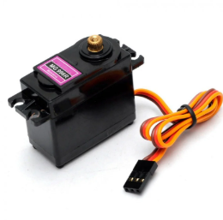
We decided to pick MG996 Servo as our actuator for the following reasons:
- Both the r.m.s. and maximum torques calculated above fall within the operating limits of the actuator.
- Our assumed motor inertia is larger than rotor inertia, meaning there is no doubt that the actuator can easily control the axis.
- This motor will allow us to control the distance moved by our pusher in order to feed the parts one at a time.

